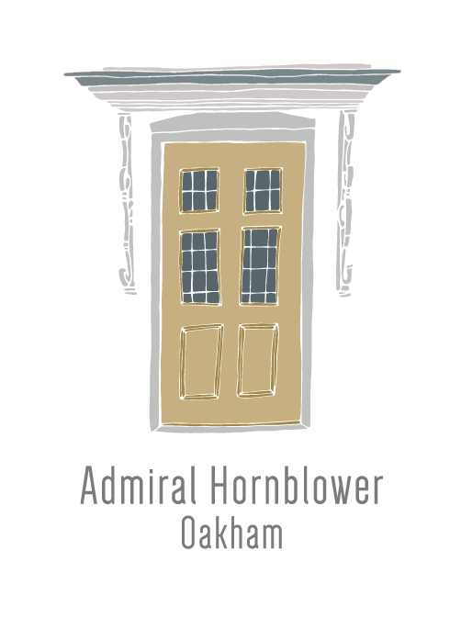
Pre-order Form
(for bookings of 8 or more)

Thank you for choosing to dine at The Admiral Hornblower. As a fresh food restaurant all our food is prepared on the premises and in order to ensure the smooth running of your party we would kindly ask if you could complete the food pre order form below and submit it to us at least five days prior to your booking. If a member of the party has any special dietary requirements, allergies or intolerances, please fill out the appropriate column on the form. For tables of 8+ we do require a deposit of £10 per person upon booking to secure your table. Please note that whilst we do strive to sit large tables on the same table this is not always possible. Many thanks!

Booking Name: |  | No. Guests: |  | Time of Booking: |  | Date of Booking: |  | Deposit Amount:

Name | Starter | Main | Side 1 | Side 2 | Dessert | Tea/Coffee | Dietary req.  Allergies/Intolerances
1)
2)
3)
4)
5)
6)
7)
8)
9)
10)
11)
12)
13)
14)
15)
16)
17)

